Name: Muhammad Abubakr

Roll no: 25K-0503

Class & Section: BCS-1K

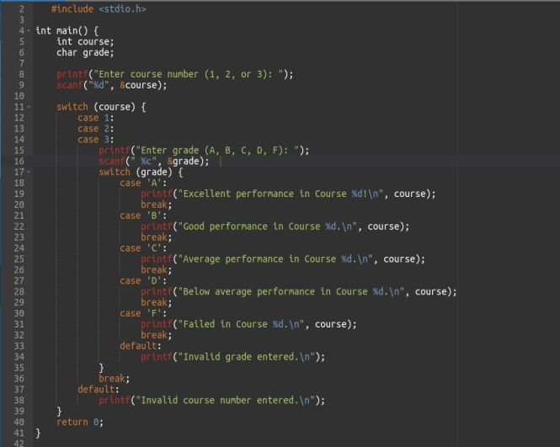TASK#5:

Output:

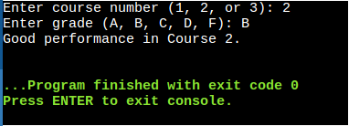

TASK#6:

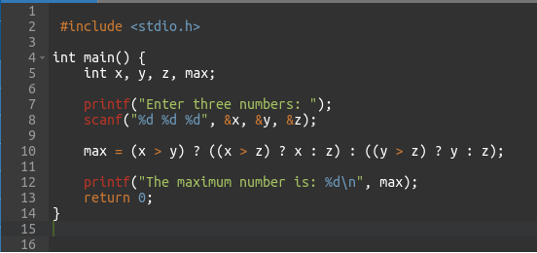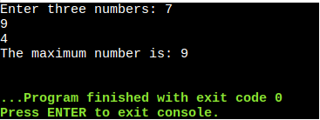

Output:

TASK#7:

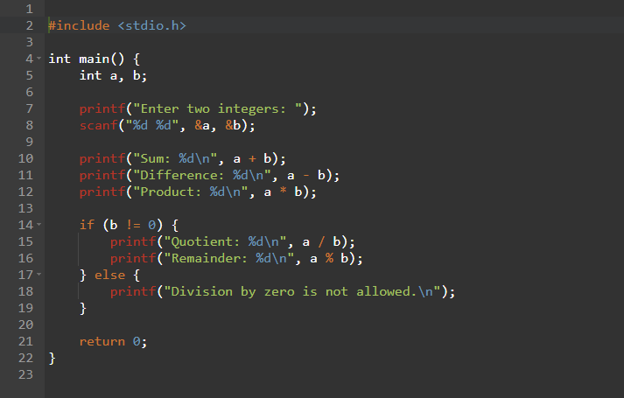

Output:

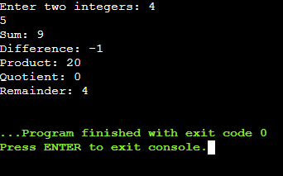

TASK#8:

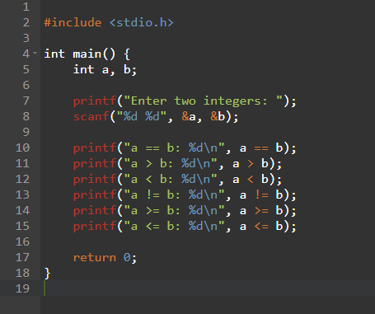

Output:

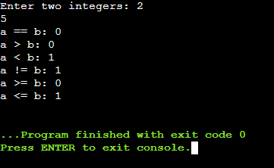

TASK#9:

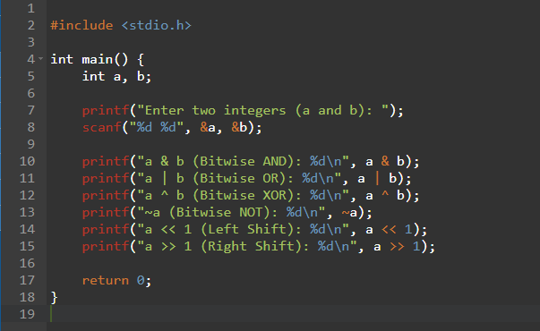

Output:

TASK#10:

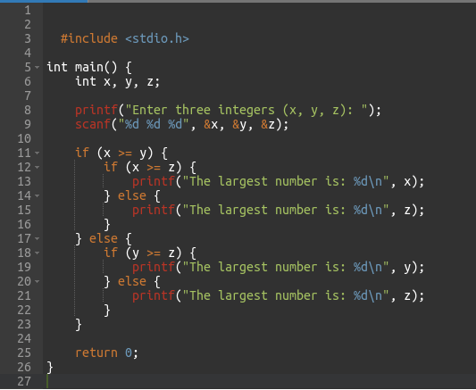

Output:

